**Assignment-6**

1.Write a query to display the name (first name and last name) for those employees who get more salary than the employee whose ID is 163.

Query:

select first_name,last_name from employees

where salary >

(select salary from employees where employee_id = 163);

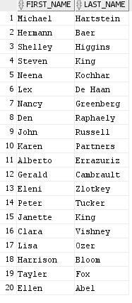

2.Write a query to display the name (first name and last name), salary, department id for those employees who earn such an amount of salary which is the smallest salary of any of the departments.

Query:

select first_name,last_name,salary,department_id

from employees

where salary in

(select min(salary)

from employees

group by department_id);

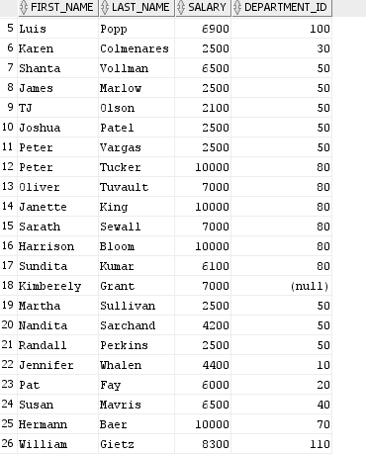

3.Write a query to display the department number, name (first name and last name), job_id and department name for all employees in the Finance department.

Query:

select first_name,last_name,job_id

from employees

where department_id in

(select department_id from departments where department_name='Finance')

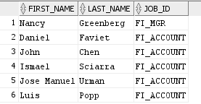

4.Write a query to display all the information for those employees whose id is any id who earn the second highest salary

Query:

SELECT * FROM employees WHERE employee_id IN

(SELECT employee_id FROM employees WHERE salary in (SELECT MAX(salary) FROM employees WHERE salary < (SELECT MAX(salary) FROM employees)));



5.Write a query to display the employee number, name (first name and last name), and salary for all employees who earn more than the average salary and who work in a department with any employee with a J in their name

Query:

SELECT employee_id, first_name , salary FROM employees WHERE salary > (SELECT AVG (salary) FROM employees ) AND department_id IN

(SELECT department_id FROM employees WHERE first_name LIKE '%J%');

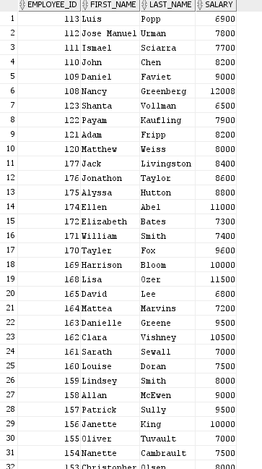

7.Write a query to display the employee name( first name and last name ) and department for all employees for any existence of those employees whose salary is more than 3700

Query:

select first_name,last_name,department_id

from employees

where exists (select * from employees where salary > 3700);

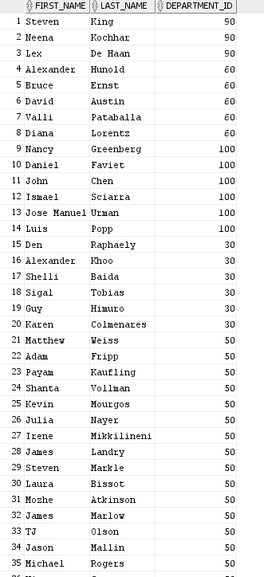

8.Write a query that will identify all employees who work in departments located in the United Kingdom

Query:

SELECT first_name FROM employees WHERE department_id IN

(SELECT department_id FROM departments WHERE location_id IN

(SELECT location_id FROM locations WHERE country_id =

(SELECT country_id FROM countries WHERE country_name='United Kingdom')));

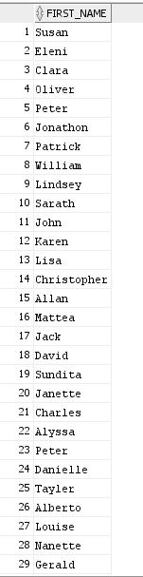

9.Write a query to get the details of employees who manage a department

Query:

select *

from employees

where employee_id = any

(select manager_id from departments);

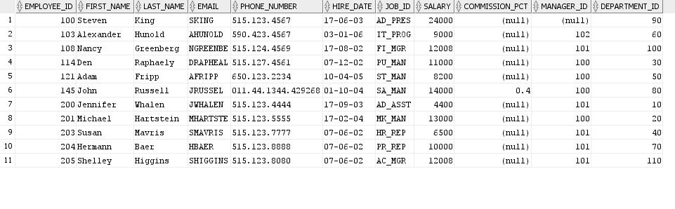

6.Write a query to display the employee number, name (first name and last name) and job title for all employees whose salary is smaller than any salary of those employees whose job title is MK_MAN.

Query:

SELECT employee_id,

first_name,

last_name,

job_id

FROM employees

WHERE salary < ANY (SELECT salary

FROM employees

WHERE job_id = 'MK_MAN')

AND job_id != 'MK_MAN';

